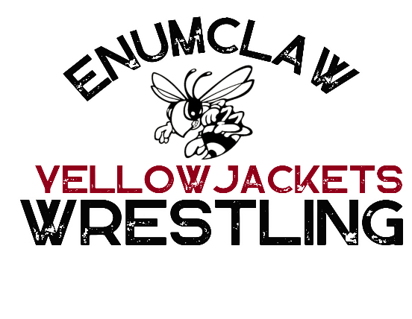
2025 – 2026 Sponsorship Request
Enumclaw Yellow Jackets Junior Wrestling club is part of the Pierce County Junior Wrestling League (PCJWL) consisting of 20 teams. We serve the Enumclaw area youth from ages 5 years old to 12 years old. We are dedicated to empowering young athletes through discipline, camaraderie, and skill development, Enumclaw Junior Wrestling Team is committed to fostering a culture of resilience, sportsmanship, and excellence. Our mission is to inspire passion for the sport, cultivate mental and physical strength, and instill values of integrity and determination, preparing our athletes for success both on and off the mat.
We can’t do this without your help. This year funds raised will go towards new team singlets, team warm-up shirts, tournament fees and facility fees. Every dollar raised helps us keep the cost to our families as low as possible so every child has the opportunity to participate. It may be an individual sport when the match starts but we are a family before and after. Please check out our sponsorship levels and see what level best fits for your company or family?
Thank you for supporting our club!
2025 – 2026 SPONSOR INFORMATION

$2,500+ Platinum
*Team Item with Company Logo On it
* Company logo on team warm up item worn at approximately 13 Matches
(company will receive one of these items in whatever size request)
* Yellowjackets team plaque for display.
*Sponsor Name and Logo on banner displayed at all matches
* Website placement and Facebook shoutout weekly for 1 year.

$2,000 Gold
* Company logo on team warm up item worn at approximately 13 Matches
(company will receive one of these items in whatever size request)
* Yellowjackets team plaque for display.
*Sponsor Name and Logo on banner displayed at all matches
* Website placement and Facebook shoutout weekly for 1 year.

$1,500 Silver
* Company logo on team warm up item worn at approximately 13 Matches
(company will receive one of these items in whatever size request)
* Yellowjackets team plaque for display.
*Sponsor Name and Logo on banner displayed at all matches.
* Website placement and Facebook shoutout monthly for 1 year.

$1000 Bronze
*Sponsor Name and Logo on banner displayed at all matches.
* Website placement and Facebook shoutout for 1 year.

$500 White
*Website placement and Facebook shoutout for 1 year.

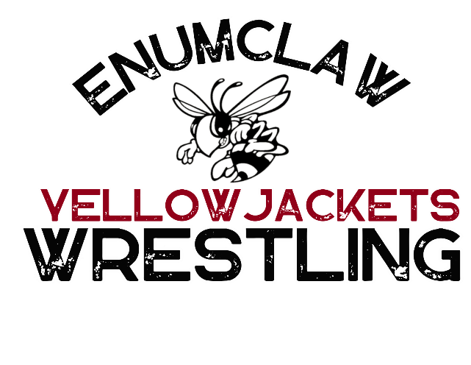
Please “X” the appropriate level
______ Platinum Sponsor $2,500+ ___Shirt Size
______ Gold Sponsor $2,000 ____Shirt Size
______ Silver Sponsor $1,500
______ Bronze Sponsor $1,000
______ White Sponsor $500

Company Name _______________________________________________________________
Contact Person_________________________________________________________________
Address_______________________________________________________________________
City_________________________________ Zip___________
Phone _______________________________________________________________________
Email________________________________ Website Address: ________________________
Write checks to Enumclaw Junior Wrestling

Send company logo to Enumclawjrwrestling@outlook.com as soon as possible, no later than September 22

Enumclaw Yellow Jackets would like to Thank You for your Sponsorship!
We are a 501(c) 3
Our Tax ID Number is 35-2264532
Griffin Ave #947, Enumclaw, WA 98022

